CST8333 Programming Language Research Project

# WBS, Gantt, Requirements and Resources.

## WBS: Example of expected format

Tip: MS Word has a bullet style that will do the hierarchical numbering, see the image below to use it, and then use the indent button in the ribbon to create sub-tasks. Alternatively, manually create the numbers and indent with tab keys. Note: Do not use a table, or a chart / text-bubble style WBS. Your WBS should be easily edited in a text editor like Notepad, if needed.

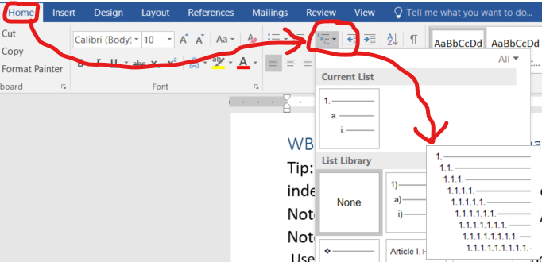

As per the image above, use the Home Tab, then Multilevel List Option or Button, then in the list library the item with 1. and 1.1. etc. was selected:

1. Practical Project Part 1
   1. Research and Learning
      1. How to create simple program
      2. Language basics, syntax
      3. Language coding style
      4. Language commenting style (document code)
   2. Development and Learning
      1. Create simple program, based on provided data set
   3. Testing
      1. Verify program output meets expectations
   4. Documentation
      1. Comment program
      2. Screen shots of running program
      3. Write up MS Word document
   5. Delivery
      1. Practical Project Part 1 Submitted

You may use the WBS above for your first Research Assignment Work Breakdown Structure. However, research Assignments 2, 3 and 4 will require you to figure out the needed WBS on your own.

## Gantt: Example of expected format

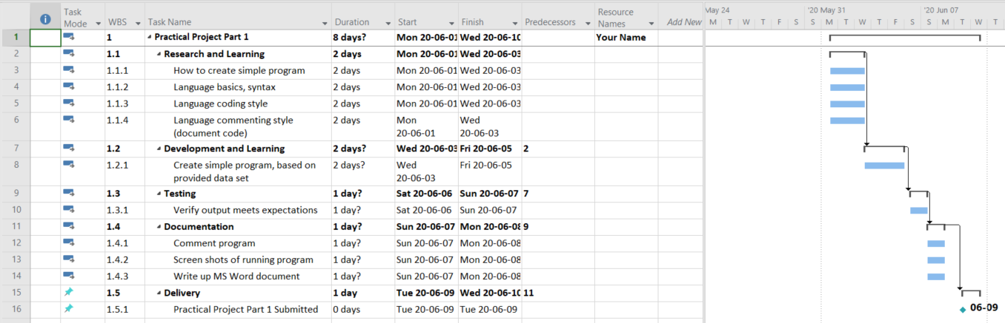

* The tasks were typed into Excel first in separate rows in a single column, and then copied from Excel into MS Project, this way all the tasks are placed on separate rows in the Gantt. I indented sub-tasks using the indent-task button. I dragged and dropped the timeline bars of earlier tasks to their following task to use automatic scheduling setting each task with automatic scheduling. E.g., the higher-level tasks like Research and Development are in sequence, while the sub-tasks under each run in parallel.
* Automatic scheduling was turned on for most of the tasks in the Task Mode Column
* Durations that were entered manually have no ‘?’ in the Duration column, durations that were estimated automatically by MS Project have ‘?’ to alert a project manager to verify by manually tying in the value. (Dale Howard, July 6, 2018)
* The “Add New Column” drop down was used to add the WBS column, which was automatically populated with numbers that should match the WBS created earlier.
* MS Project defaults to a 5-day work calendar, to adapt to the course delivery, which is 7 days a week so a 7-day calendar was created and applied. There is a website below with steps on how to set to 7-day workweek calendar.
* The milestone was given a duration of zero, and should have the due date for the Practical Project Part set manually. Durations can be tweaked but the delivery of the Practical Project Parts is fixed by your professor.
* Replace the “Your Name” with your actual Student Name as seen in ACSIS.

NOTE:

Getting exact dates and times in the Gantt chart is not required in this course, excepting the due date for the delivery milestone. Dates for time estimates can be one to two days off from what would be expected in the current semester. Your professor is looking for the items in the Rubric (Grading Section) and not looking for perfect scheduling of tasks.

Your Discussion Forum assessments will ask you to reflect on your time estimates. If your time estimates turn out to be wildly inaccurate, but your Practical Project Parts (1, 2, 3 and/or 4) comes in on time, this is okay. For this course the process of estimating time, researching, learning and applying, documenting, reflecting is more important than good time estimates. You will get better at estimating time as the course progresses.

## Recommended Readings

Dale Howard. (July 31, 2018). About Those Pesky Question Marks in the Duration Column. [website] Retrieved from: <https://www.mpug.com/pesky-question-marks-duration-column/> [Last Accessed on May 23, 2022]

BWContractor. (December 9, 2016). Project Default to Calendar Days, Not 5 Day Work Week!. [website] Retrieved from: https://answers.microsoft.com/en-us/msoffice/forum/all/project-default-to-calendar-days-not-5-day-work/d50fe2b7-c46e-4b36-871d-6b1a21a61f57 [Last Accessed on May 23, 2022]

## Project Management Software: Microsoft Project or ProjectLibre and Learning Resources

If your computer **is** using a Windows Operating System **and** you can get MS Project from the Microsoft Azure Portal (<https://aka.ms/devtoolsforteaching> )

* Get Microsoft Project 2019 (or newer)
* Reference Recommended Book
  + Microsoft Project 2019 Step by Step (May 25 2019) by Cindy Lewis, Carl Chatfield, Timothy Johnson. Microsoft Press; 1st edition, ISBN-10: 1509307427, ISBN-13: 978-1509307425
  + NOTE: This book is available free, digitally, on Safari, via the School Library Website.
* The recommended book is available in Safari Books online in the school library. look for information on task entry, create sub-tasks, link sequential tasks, milestones

OR

If your computer **is not** using a Windows Operating System **or** you are having trouble obtaining MS Project

* Get ProjectLibre Community Edition from <http://www.projectlibre.com/>
* Recommended Learning Resources
  + project-management.com. (September 15, 2016). ProjectLibre Tutorial Part 1: Creating Your First Project. Retrieved from <https://project-management.com/projectlibre-tutorial-part-1/>
  + project-management.com. (May 1, 2015). ProjectLibre Tutorial Part 2: Task breakdown, Resources. Retrieved from https://project-management.com/projectlibre-tutorial-part-2/
* Read all parts of tutorial 1, then read tutorial 2 up to where you learn to add yourself as a resource, (there is no need to continue with project costs calculations.)
* Tip: Do not use a forward scheduled Gantt, our course has a strict due dates with the delivery of each Practical Project Part (1, 2, 3 and 4).

**Note:**

* **ProjectLibra will run on a windows operating system, for example if the license period for your digital resources portal copy of MS Project has expired.**
* **MS Project is the preferred software but you may use either MS Project or ProjectLibra files.**